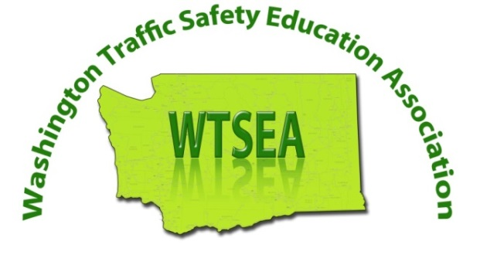 | 2017 WTSEA FALL CONFERENCE AGENDA  OCTOBER 13th and 14th  “WORKING TOGETHER”  RENTON TECHNICAL COLLEGE  3000 NE 4TH STREET  RENTON, WA 98056

FRIDAY AFTERNOON (TSE COORDINATOR WORKSHOP – 3 CLOCK HOURS) HOURS
1:00-4:00 | ESHB 1481 & PUBLIC SCHOOL TSE – PREPARING FOR DOL AUDITS | ALEX HANSEN, DOL & OSPI | 3

FRIDAY EVENING (PRE-CONFERENCE - 3 OR 4 CLOCK HOURS)
5:00-9:00 | CPR & FIRST AID | CHUCK FILIPPINI | 4
6:00-9:00 | “FROM CHUCK WAGONS TO DRIVERLESS CARS” | LOU GERVINO | 3

SATURDAY MORNING (CONFERENCE - 3.5 CLOCK HOURS)
7:00-8:00 | CONTINENTAL BREAKFAST & CONFERENCE REGISTRATION
8:00-8:25 | INTRODUCTIONS & INSTRUCTIONS - CLOCK HOURS, ETC… | MIKE SHEPHARD | .5
8:25-9:55 | “IMPROVING YOUR DRIVER EDUCATION PROGRAM” | LOU GERVINO | 1.5
9:55-10:20 | INTRO SPONSORS & NETWORKING | GERRY APPLE & SKEET GAUL | .25
10:20-11:50 | “TRAUMA NURSE’S TALK TOUGH” | SHELLEY CAMPBELL | 1.5

LUNCH
11:50-12:30 | LUNCH & AWARDS | GERRY APPLE & CHUCK FILIPPINI

SATURDAY AFTERNOON GENERAL SESSION CHOICES - CHOOSE ONE (1.5 CLOCK HOURS)
12:30-2:00 | “UPDATE ON RULES & POLICIES” | DOL STAFF (CASEY SCHAUFLER) | 1.5
12:30-2:00 | “ESHB 1481 – IMPLICATIONS & WHAT’S NEXT?” | ALEX HANSEN | 1.5
2:00-2:20 | NETWORKING & BREAK | SPONSORS | .25

SATURDAY BREAKOUT CHOICES - CHOOSE TWO (1 CLOCK HOUR EACH SESSION)
2:25-3:25 | “DRIVING AGE VS. MATURITY” | JOHN CLARK | 1
2:25-3:25 | “WASHINGTON STATE MADD” | MICHELLE DAVIS | 1
2:25-3:25 | “KEY R.O.W. LAWS - GETTING ON THE SAME PAGE” | ALEX HANSEN | 1
2:25-3:25 | “STATE PATROL- ENFORCEMENT UPDATES & POINTS OF EMPHASIS” | SERGEANT WRITE | 1
2:25-3:25 | “TRUCK SAFETY” | MIKE SOUTHARDS | 1
2:25-3:25 | “UTILIZING STUDENTS IN YOUR TSE PROGRAM” | SHELTON SADD CLUB | 1

3:25-3:30 | PASSING TO 2ND WORKSHOP CHOICE

3:30-4:30 | ALL WORKSHOPS WILL BE REPEATED…. ATTEND YOUR 2ND WORKSHOP CHOICE | 1

4:30-4:35 | PASSING TO CLOSING COMMENTS

4:35-5:00 CLOSING COMMENTS & NETWORKING STAMP (1 CLOCK HOUR FOR NETWORKING) .5
NOTE: MUST RECEIVE NETWORKING STAMP TO EARN NETWORKING CLOCK HOURS

